

Key findings at a glance

**VOLUMES**The volume of remortgages hit an eight-year high in June – based on a 12-month rolling average – with September 2009 being the last time current transaction levels were witnessed. Current levels are still some way off those seen before the global financial crisis, but compare with anything we’ve seen since.

**LOAN AMOUNTS**  
Loan amounts hit an all-time high – with the current average remortgage worth £171,421 based on a three-month rolling average.

**BROKERS**The number of borrowers consulting a broker when remortgaging has risen from 70% in July 2017 to 83% in July 2018.

**PURPOSE OF LOANS**  
The proportion of borrowers remortgaging to pay off debt fell to 11% in July, down from 16% in June – the lowest percentage since the 10% registered in January. The most popular reason for borrowers to remortgage remains reaching the end of a fixed-rate deal (75%) while home improvements were also cited as a reason to remortgage by 25% of remortgagors.

Quick quote

**“Remortgaging volumes have been on an upward trend since the beginning of 2015 and the current 12-month rolling average shows an eight-year high. Growth has been driven by a combination of factors. People tracking rates to secure a fixed-rate deal ahead of a potential rate change over the summer, and a flurry of borrowers, correlating with a previous spike in the market. Back in the summer of 2016 interest rates hit a record low and people fixed on the rates available at that time on two-year deals. These borrowers are now reaching the end of their current arrangement and are returning to the market.”**

Nick Chadbourne, chief executive of LMS

71%

expect rate rises

. . . . . . . . . . . . . . . . . . . . . . . . . . . . . . . . .

27%

expect no change

. . . . . . . . . . . . . . . . . . . . . . . . . . . . . . . . .

2%

expect rate falls

Interest rate expectations

Fast facts:

8 years

Volume of remortgages (12-month average) hits eight-year high

. . . . . . . . . . . . . . . . . . . . . . . . . . . . . . . . .

£171,421

Average loan amount hits record high (based on 3-month rolling average)

. . . . . . . . . . . . . . . . . . . . . . . . . . . . . . . . .

19.5%

Average repayments as a % of income

. . . . . . . . . . . . . . . . . . . . . . . . . . . . . . . . .

2.3%

of borrowers remortgaged to reduce their term in July, down from 3.2% a year ago

Record remortgaging resilient to changing landscape, says LMS

**Remortgage Report**

Remortgage product type

Variable rate mortgages increased in popularity in July, accounting for 3% of remortgages, up from 1% in June.

Five-year fixed rate remortgages remain the most popular product type, representing more than two-fifths of transactions (43%), increasing from 42% in June.

Two-year fixed rate remortgages now account for 24% of all products, down from 25% in June.

Remortgaging to reduce term

|  |  |  |  |
| --- | --- | --- | --- |
| Remortgaging to shorten term | Jul-16 | Jul-17 | Jul -18 |
| **Percentage of remortgagors** | 2.9% | 3.2% | 2.3% |

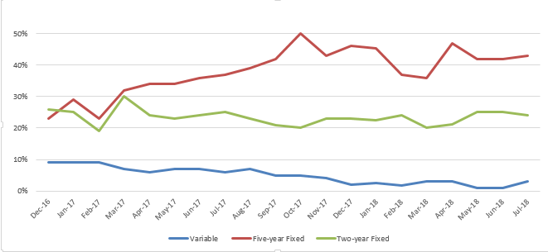

43%

of borrowers chose five-year fixed rate remortgages in July

Two-year fixed rates are the next most popular, accounting for 24% of the market

3%

of remortgagors opted for a variable rate in July

A significant increase from just 1% of all transactions in June

3.3%

increase in remortgage activity between May and June 2018

Meaning overall volumes have hit an eight-year high (based on 12-month rolling average)

The proportion of homeowners remortgaging to reduce their mortgage term fell to 2.3% in July 18; down from 3.2% in July 2017 and 2.9% in June 2016. This percentage has also fallen in recent months, down from 2.4% in May and June 2018.

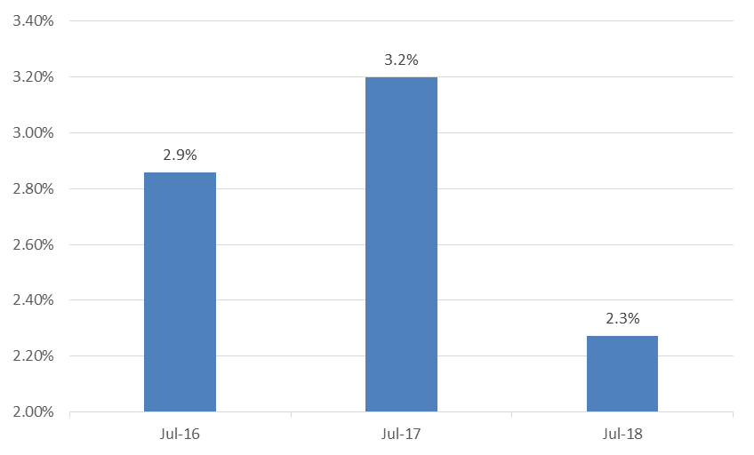

**Affordability and loan amounts**

Affordability – Key findings at a glance:

Despite household incomes climbing back above £48,000 for the first time since August 2017, rising interest rates mean that annual repayments have hit a four-year high – payments haven’t been this high since June 2014 when they hit £9,527. As a result of this, the percentage of income accounted for by yearly mortgage costs has risen to 19.5%, the highest proportion since January 2016.

|  |  |  |  |  |
| --- | --- | --- | --- | --- |
|  | Household  Income (£) | Interest rate (%) | Annual repayment (£) | Annual repayment as % of income |
| **Jun-18** | 48,139 | 2.11 | £9,380 | 19.5 |
| **May-18** | 47,350 | 2.11 | £8,636 | 18.2 |
| **Jun-17** | 47,210 | 2.06 | £8,071 | 17.1 |

Mortgage rates:

19.5%

Average annual repayments as a percentage of income

Highest level since Jan 2016

77%

of those remortgaging managed to lower their interest rate in July

This is 12 percentage points below the 89% high seen in November 2016

£171,421

Typical remortgage loan amount

The highest average size recorded by LMS

With interest rates on the rise, the percentage of those able to lower their rate by remortgaging fell to 77% in July, down from a high of 89% in November 2016.

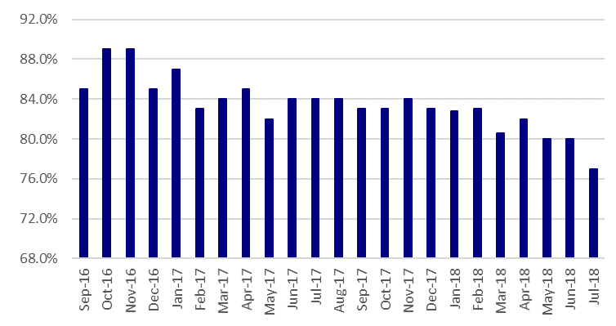

Lowered mortgage rate by remortgaging

Loan amounts:

The typical remortgage loan amount has hit a record high of £171,421 based on a three-month rolling average.

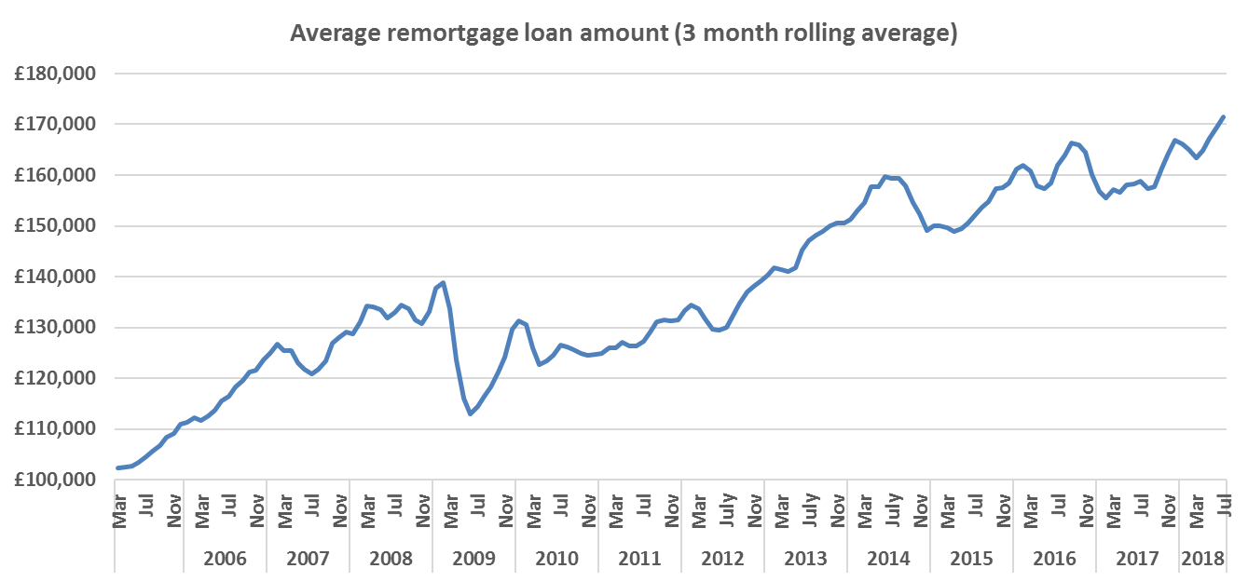

Regional trends

* Highest LTV is 93% found in the North East
* Highest average regional remortgage amount breaks the £300K barrier – typical London loans now stand at £311,331
* Fastest remortgaging frequency also in the capital – an average of three years and five months

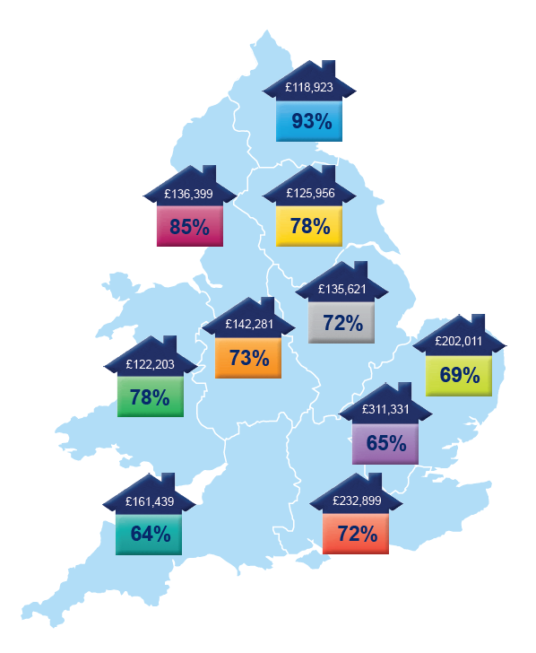

64%

Lowest average LTV

The lowest average LTV in July found in the South West

52 months

Least frequent remortgaging

On average, homeowners in Wales remortgaged least frequently in July – every four years and four months

£119k

Lowest remortgage loan size

The lowest average remortgage loan size in July was in the North East – £118,923

**Length of mortgage**

**Average loan amount**

|  |  |  |  |
| --- | --- | --- | --- |
| Region | July 18 (Months) | June 18 (Months) | Change  (Months) |
| East Anglia | 42 | 56 | -14 |
| East Midlands | 43 | 66 | -23 |
| London | 41 | 57 | -16 |
| North East | 51 | 70 | -19 |
| North West | 45 | 61 | -16 |
| South East | 43 | 58 | -15 |
| South West | 47 | 56 | -9 |
| Wales | 52 | 65 | -13 |
| West Midlands | 47 | 63 | -16 |
| Yorkshire | 46 | 58 | -12 |

Average LTVs in the North East hit 93% in July; up from 82% in June. The region currently has the lowest typical loan amount, however (£118,923). While nine regions throught England & Wales have seen LTVs rise, Yorkshire saw LTVs unmoved at 78%.

Remortgagors in the capital are currently only borrowing 65% of their property’s value, although this is up from 60% in June and still equates to £311,331. London borrowers are also remortgaging most often; every three years and five months according to the latest LMS data.

About LMS

LMS’s UK remortgage lending estimates are based on LMS’s up to date internal conveyancing data, which, every month, covers many thousands of remortgage completion transactions. LMS (Legal Marketing Services) is one of the UK’s largest providers of outsourced property services, including conveyancing, remortgage and IT services. Each year LMS successfully manages over 200,000 transactions, helping to enable more than £30 billion in loans for intermediaries and lenders. The LMS system is based on the company’s unique STARS (Servicer Tracking & Reporting System) technology which manages transactions electronically on-line to ensure speed, cost efficiency and quality of service.

**To find out more about LMS, visit www.lms.com**